Results and Cases of the US-Taiwan Eco-Campus Partnership Program
- Background
Eco Schools Global was initiated by the Foundation for Environmental Education (FEE). Over the past 25 years, FEE has continued to attract participation from many countries around the world. Eco Schools Global is now the largest environmental education program in the world! Prior to our membership in FEE, we established the US-Taiwan Eco-Campus Partnership through collaboration with the U.S. Environmental Protection Agency (US EPA), the National Wildlife Federation (NWF), and various other organizations within and outside the country to make this worthwhile program available to schools in Taiwan.
- Executive Results
The US-Taiwan Eco-Campus Partnership Program has been operating for eight years since it was launched in 2014. To date, over 500 Taiwanese schools have joined the program and around 300 schools have received certification. Among the certified schools, 13 received Green Flags, 116 received Silver Awards, and 175 received Bronze Awards. Over 20,000 teachers and 240,000 students have participated in the program.
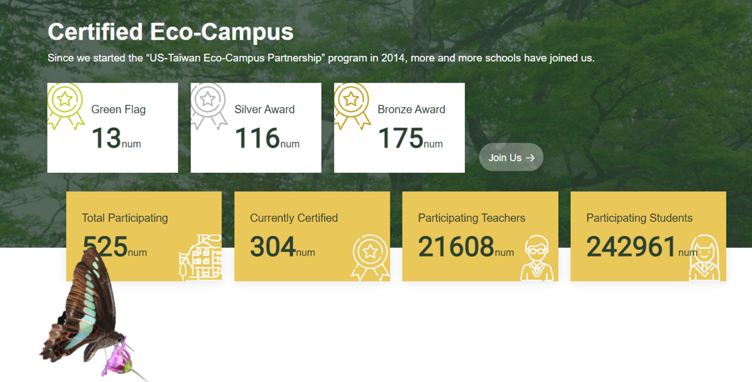
Results of the US-Taiwan Eco-Campus Partnership Program
- Core Spirit and Executive Process
The Eco-Schools Program aims to develop learner autonomy. Students are encouraged to participate in discussions and make decisions proactively. During the process, what students receive is more than passive learning. They have the opportunity to take the initiative to explore the environment, take action, and even mobilize and change their communities. The program also serves as a framework for teachers in guiding students to participate in discussions or make group decisions. The program is conducted through the Seven Steps Methodology and 12 EcoCampus Themes (i.e., environmental issues). Students, school managers, faculty members, and community volunteers form a team to integrate available resources and realize green management. The program is then implemented based on the resources, such as lands, facilities, and courses that the school can provide.
Source: US-Taiwan Eco-Campus Partnership Program website (https://ecocampus.epa.gov.tw/about/school_result)
- Cases of Green Flag Schools
Since the US-Taiwan Eco-Campus Partnership Program was launched in 2014, 13 schools in Taiwan have been awarded Green Flags. These schools have not only implemented environmental education in the formal education system, but also influenced their communities and taken concrete action to conserve the environment. Among them are two schools, Micang Elementary School in New Taipei City and Hushan Experimental Elementary School in Tainan City. The following is what they have achieved:
- Micang Elementary School — Saving Crabs Using Maps
Micang Elementary School, which has 19 classes and 357 students, is located beneath Mount Guanyin and resides along the Tamsui River. Since the school joined the US-Taiwan Eco-Campus Program in 2014, they have focused on the EcoCampus Themes of energy, consumption and waste, sustainable eating, and schoolyard habitats. An action group of 23 students was split into small teams to conduct an environmental review on campus and reported the results to all students and faculty members. The group also launched initiatives to reduce food waste and garbage, build on-campus habitats, protect red-clawed crabs, and take many other environmental actions. In 2021, the school was awarded a Green Flag by the Eco-Schools Program.
Principle Ai-Ling Lin said that due to the school's proximity to the Tamsui River, students often see road kills of the Chiromantes haematocheir terrestrial crabs. As students would feel sorrowful, they established a conservation area for terrestrial crabs on campus and posted a Crab Map to raise awareness on Earth Day in 2020. They observed the entire left bank of the Tamsui River to determine when and where the crabs would appear and acted to protect the local ecosystem.
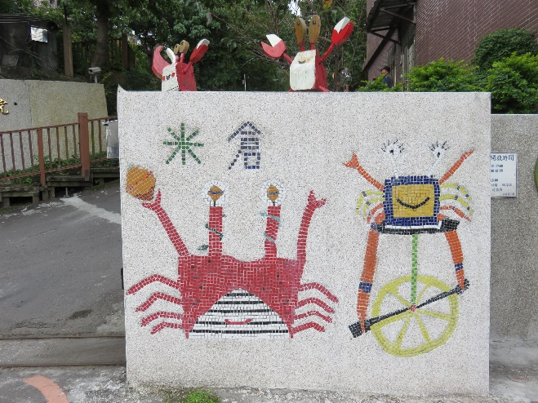
Red-clawed crabs (Chiromantes haematocheir) being featured by Micang Elementary School
A map drawn by students that shows red-clawed crabs’ routes around campus
Micang Elementary School students drew signs on Earth Day to inform people of the crabs’ hot spots (Photo credit: US-Taiwan Eco-Campus Partnership Program)

School officials stated that after joining the Eco-Schools Program, students became more aware of environmental issues around them and began taking action to protect the environment. They would observe, record, and discuss solutions. They would also monitor the progress by themselves, express their ideas, and even invite their classmates to join their environmental initiatives.
- Hushan Experimental Elementary School — A Pioneering Eco-school with Glocal Spirit
Previously an elementary school for children of Rende sugar mill employees in Tainan, Hushan Experimental Elementary School was facing closure several years ago due to a diminishing number of students. After joining the US-Taiwan Eco-Campus Partnership Program driven by the United Nations (UN) Sustainable Development Goals (SDGs), the school strove to create an environmentally-friendly campus and a sustainability paradise for children. Teachers started to teach using innovative approaches. Parents and the local community acknowledged the school and praised it for its effort. The school was awarded Green Flags in both 2015 and 2018.
Principle Yung-Cheng Lin said that through the effort of all the faculty members, the school developed a curriculum that features low carbon and environmental protection — Exploring Biodiversity: The Seeds of Trees for the first and second graders, Sustainable Forestry: Collecting Twigs and Sticks for the third and fourth graders, and Cuisine of Mother Gaia for the fifth and sixth graders. To conduct its environment-oriented courses, the school also integrated off-campus resources.
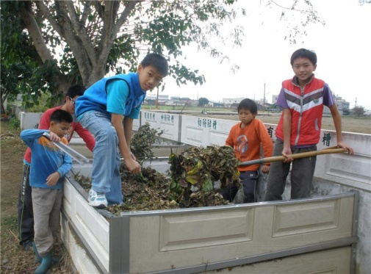
This is part of the Cuisine of Mother Gaia courses, where students are able to plant, take care of, harvest, and cook what they have planted. (Photo credit: Hushan Experimental Elementary School)

Moreover, the teachers shared the results by submitting a paper on the topic of Sustainable Forest: Campus Treasure-hunt to Finnish environmental education journal Ympäristökasvatus. It was accepted for publication, thus making the school the first in Taiwan to have its teaching results published in a Finnish journal. The faculty members also went to Europe and the US during the summer break to share their experience in conducting Eco-School courses and integrating SDGs into education. Through exchanging ideas with multiple overseas Eco-Schools, Hushan Experimental Elementary School not only gains new momentum, but also spreads these novel teaching ideas to more countries outside of the US-Taiwan Eco-Campus Partnership Program.
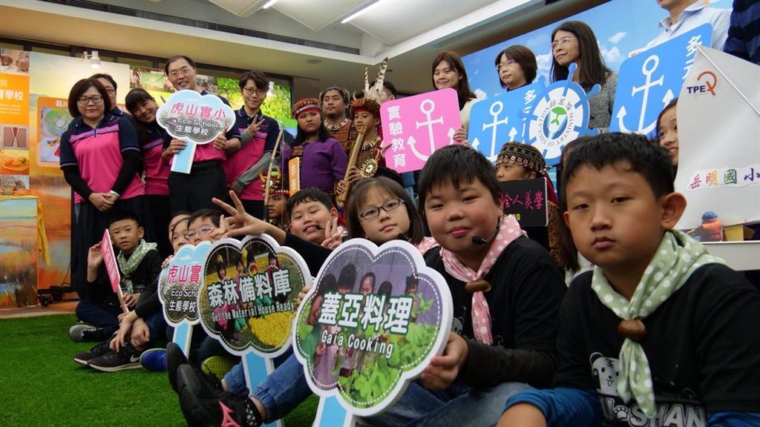
Presentation of the US-Taiwan Eco-Campus Partnership Program
- Conclusion
This year marks the eighth year of the US-Taiwan Eco-Campus Partnership Program in Taiwan. In line with the new curriculum guidelines promulgated by the Ministry of Education, the Program is learner-centered and promotes self-directed learning and life-oriented values in environmental education. It also encourages students to engage in both the local and international communities. In the future, Taiwan will continue to promote the US-Taiwan Eco-Campus Partnership Program to enlighten more students and guide them through environmental education.

